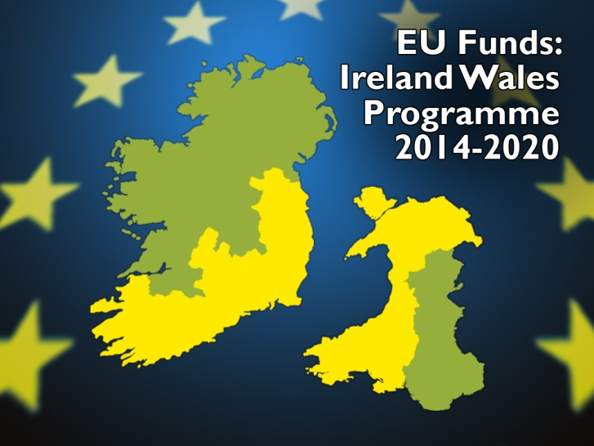
Clár na hÉireann na Breataine Bige - Rhaglen croes-ffiniol Iwerddon Cymru
Ireland Wales Programme 2014-2020
Wales Ireland Networking (WIN3) Scheme - Travel CONFIRMATION Form

PLEASE REFER TO THE ELIGIBILITY TERMS WHEN COMPLETING THIS FORM.

SECTION A – CONTACT DETAILS

Applicant Organisation Name
Address for Correspondence
Telephone
Email Address
Contact Person
* Please ensure that the declaration in Section D is signed.

SECTION B – TRAVEL DETAILS

Date of Travel
Outward Date |  | Return Date

Names of the persons who travelled
 | Name | Organisation & Position | Contact Telephone | Contact Email
1
2
3
4
5

Brief description of your visit to Ireland/ Wales.
- Details of the persons/organisation you met at your destination & dates of meeting.

Please outline any changes to your travel plan during your trip compared to your travel proposal form.

SECTION C – CONFIRMATION OF TRAVEL

Name | Date Of Travel | Confirmation Document Details  e.g. Boarding Pass

SECTION D - DECLARATION

DECLARATION I / We certify the accuracy of the information presented and is in accordance with the aims of the Ireland Wales Programme 2014-20 Co-operation Programme.

Signed _______________________________ Date _____________________

Print Name _______________________________ Position ___________________

OFFICE USE ONLY

Joint Technical Secretariat
Date Received
Confirmation Document
Total Expenses
Valid Claim | Yes □ No □
Comments

Signed: _________________________________ Date: ______________

Managing Authority
Date Received
Approved Travel Plan | Yes □ No □
Approved Amount |  | Payment Approved | Yes □ No □
Comments

Signed: _________________________________ Date: ______________

Certifying Authority
Date Received
Payment Amount
Date Payment Issued |  | Payment Ref
Comments

Signed: _______________________________ Date: ______________

