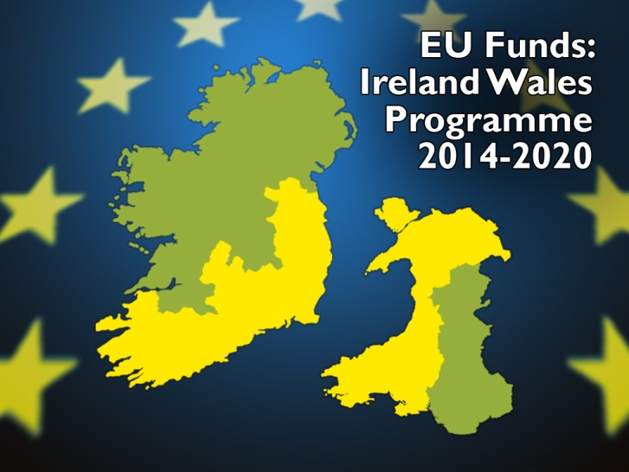

Clár na hÉireann na Breataine Bige - Rhaglen Croes-ffiniol Iwerddon Cymru
Ireland Wales Programme 2014-2020

Wales Ireland Networking (WIN3) Scheme - Travel PROPOSAL Form

SECTION A – CONTACT DETAILS

Applicant Organisation Name
Address for Correspondence
Telephone
Email Address
Contact Person
Organisation’s current activity & legal status
* Please ensure that the declaration in Section D is signed.

SECTION B – TRAVEL PROPOSAL

Proposed travel dates
Outward Date |  | Return Date

Names of the persons intending to travel
 | Name | Job Title | Contact Telephone | Contact Email
1
2
3
4
5

Purpose of your intended visit to Ireland or Wales
Provide details of the persons/organisation you will be meeting.

SECTION C – PROJECT INFORMATION

Please indicate under which Priority/Theme your proposed project will be submitted.
Priority 1 | Cross-border Innovation
Priority 2 | Adaptation of the Irish Sea and Coastal Communities to Climate Change
Priority 3 | Cultural and Natural Resources and Heritage

Brief description of the proposal you are developing & details of the partnership.

SECTION D - DECLARATION

The details above form the basis upon which approval to travel is granted under WIN 3 scheme assistance. Claims for financial assistance against the costs of activities or individuals not stated on this form will not be considered.

DECLARATION I / We declare that the purpose of this application is to assist in the development of eligible Ireland Wales Co-ooperation Programme activities.

Signed (Contact Person) |  | Date

PLEASE RETURN THIS SIGNED APPLICATION BY POST/SCANNED EMAIL TO THE JS, CARMARTHEN.

OFFICE USE ONLY

Joint Secretariat
Date Received
Amount Requested
@ Unit Cost of €250.00
Comments
Signed |  | Date

Managing Authority
Date Received
Approved Travel Plan | Yes □ No □
Comments
Signed |  | Date

